Iris Crisis
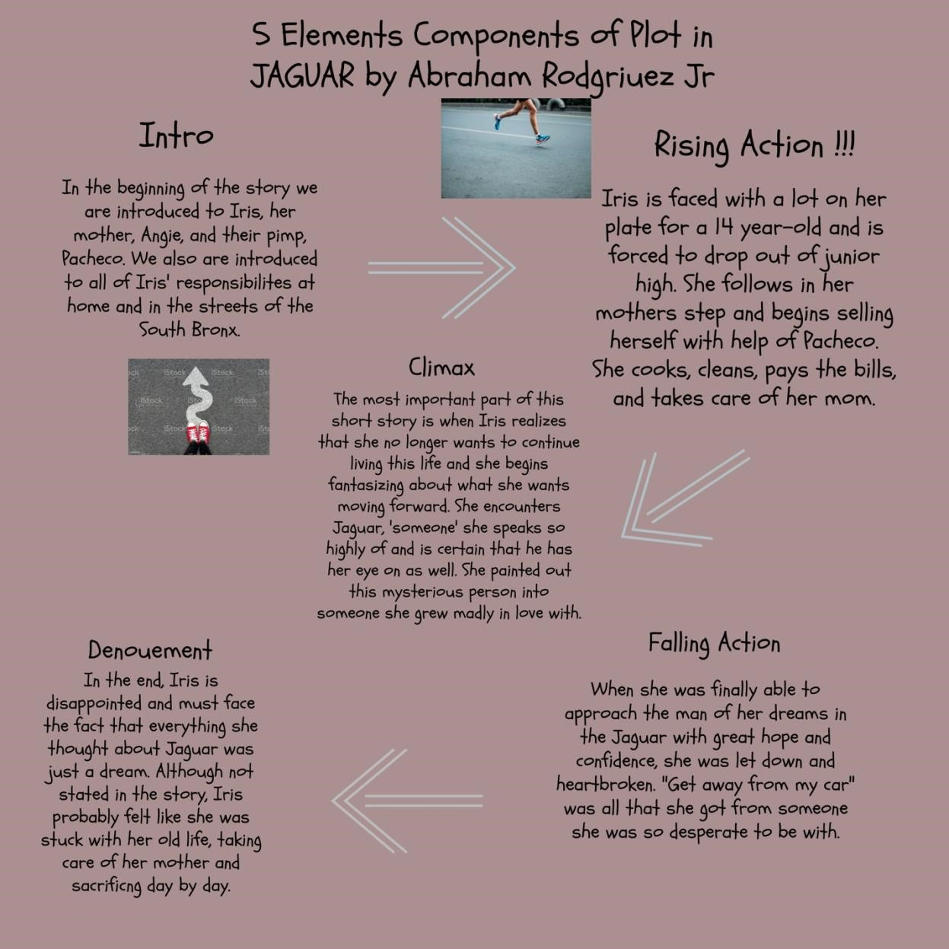
In my opinion, I was not too fond of the ending of Jaguar by Abraham Rodriguez Jr. As I read the story and put into perceptive what Iris and her mother went through, I was expecting somewhat of a happy ending. Throughout the whole short story, Iris was forced to grow up and mature in order to maintain a stable life for herself and her addict mother, Angie. Iris was ripped of her innocence and her adolescence stage when she dropped out of junior high school and sold herself with the assistance of her ‘protector’, Pacheco. However, Pacheco displayed dominator and master characteristics. He was nowhere near a father figure and neither was her mother.
Angie even referred to Iris and herself as ‘partners.’ She was pretty messed up herself and although she was scared for Iris to follow into her footsteps, she was a crack addict who was fragile and helpless. Iris was the mother figure to her own mother as she ‘cooked, cleaned, payed the bills, and took care of her mom.’ To summarize why I am upset with the ending of this story is because Iris had to endure a huge amount of adversity at an age where she would normally be gossiping with friends and crushing on boys.
The Jaguar is an important piece of this short story because it symbolizes Iris’ desperate dream and her hope for the future. When she first saw the Jaguar, she was intrigued but was immediately shut down when Pacheco forced her to stay away from him. However, Iris was already exhausted and began feeling disappointed in herself. She didn’t want to completely end up in Angie’s position, so she began to fantasize the Jaguar as her ticket out of this lifestyle. Iris painted out an image of what she wanted in a man in the Jaguar. It was like she was in love with love with something that she never seen or spoken to before. The way she spoke about it as if she were writing in her journal, “He was young, an ex-drug dealer tired of the daily kill… He wanted to take just one thing with him on his ride out.” Although she spoke so highly of Jaguar, she never approached him until she finally grew the courage to pursue her mysterious dream. In the end, she came to the unfortunate reality that Jaguar was nothing but a regular asshole in the South Bronx. She was not special, and she was not going to get rescued. This ending just did not sit right with me because she was so confident that she was going to finally get all that she’s ever wanted. As I was reading, I felt myself even getting excited for Iris as I actually thought that there was going to be a happy ending. I wasn’t satisfied with this ending because I truly had some faith that Iris was going to encounter something different. I was also not too happy about the ending because it left me wondering what Iris’ reaction to that last scene was.

